AOI ACADEMY · FULL-STACK WEB DEVELOPMENT WITH MERN
Sessions 3 + 4 · Frontend
EmployeeHub in React, one complete feature at a time
We build the app feature by feature. Every feature is finished and working before the next one starts. For each feature you get, in this order:
- The screen we are going to build (a real screenshot).
- The files we touch, and what happens in each.
- The code.
- Where every function comes from: written in which file, called from where, does it go through axios, what it returns.
- The journey of one action, from the click to the server and back to the screen.
- The test: what to do, what you should see, and the request with its method, full URL, body and expected response.

Date | Wednesday 28 October 2026 · 9:30 – 13:00
Start from | Yesterday's Session 2 API (Express + Mongoose + Atlas)
Not in this session | Login and roles: every request is public
Trainer | Ahmed Shaker

The plan
# | Feature | The user can… | Time
0 | Setup | (nothing yet) the API allows the browser · a React project exists | 09:30 – 09:50
1 | Show the employees | see every employee with the department they work in | 09:50 – 10:30
 | Break |  | 10:30 – 10:45
2 | The departments page | switch between Employees and Departments (real URLs) | 10:45 – 11:05
3 | Search, filter, pages | search by name, filter by department, move between pages | 11:05 – 11:45
 | Break |  | 11:45 – 12:00
4 | Add, edit, delete employees | manage employees with a form | 12:00 – 12:35
5 | Add, rename, delete departments | manage departments | 12:35 – 12:50
6 | Final check | everything, with errors handled | 12:50 – 13:00

If time is short
Features 1 – 4 are the session. Feature 5 repeats the same ideas: show its screens and code from the zip.

Who talks to whom (keep this picture on the board)
the rule of the whole session
The screen (a page component)
│ 1. calls a function from api.js e.g. getEmployees()
▼
api.js the ONLY file that knows URLs
│ 2. uses axios api.get('/employees')
▼
axios ──── HTTP ────► Express API (localhost:5000) ────► MongoDB Atlas
◄──── JSON ─────
│ 3. returns res.data to the page
▼
The page puts it in state: setEmployees(...)
│ 4. React draws the screen again
▼
The screen shows the new data
Word | Meaning in one line | Angular / C#
Component | A function that returns what to show (JSX = HTML inside JavaScript) | @Component + template
useState | A value that, when changed with its setter, makes React redraw | A component property
Props | What a parent passes to a child: <EmployeeRow employee={e} /> | @Input() / @Output()
useEffect(fn, []) | Run fn after the page appears (load the data) | ngOnInit()
axios | Sends HTTP requests | HttpClient
api.js | Our file with one function per request | A service

Feature 0 · Setup

1. The API: two small changes
Why: the API works in Postman, but a page in the browser needs CORS, and Feature 5 (Rename) needs PUT for departments.
terminal (inside server)
npm install cors
server/src/app.js (cors BEFORE the routes)
const cors = require('cors');

app.use(cors({ origin: process.env.CLIENT_URL || 'http://localhost:5173' }));
app.use(express.json());
server/.env (add)
CLIENT_URL=http://localhost:5173
Code | What it does / returns
Why CORS | The page comes from localhost:5173 and calls localhost:5000: another port = another origin. The browser blocks the page from reading the answer unless the server allows it. Postman is not a browser, so it never had this problem
cors({ origin }) | Adds Access-Control-Allow-Origin: http://localhost:5173 to every response

server/src/controllers/departmentController.js (add)
exports.updateDepartment = async (req, res) => {
const department = await Department.findByIdAndUpdate(
req.params.id,
{ name: req.body?.name },
{ new: true, runValidators: true }
);
if (!department) {
return res.status(404).json({ message: 'Department not found' });
}
res.json(department);
};
server/src/routes/departmentRoutes.js
router.route('/:id').put(c.updateDepartment).delete(c.deleteDepartment);
Code | What it does / returns
findByIdAndUpdate(id, { name }, options) | Finds and changes in one step
new: true | Return the department after the change
runValidators: true | Apply the schema rules on update too (empty name → 400)

Test · The API is alive
Method | GET
URL | http://localhost:5000/api/health
Authorization | None (no token)
Body | No
Expected | 200 OK

Expected response
{ "status": "ok" }

2. The React project
terminal (in the project folder, next to server)
npm create vite@latest client -- --template react
cd client
npm install
npm install axios react-router-dom
Package | What for
Vite | Creates the project and runs it (npm run dev) with live reload. Like the Angular CLI
axios | Sends HTTP requests to the API. Like HttpClient
react-router-dom | Gives every page a URL (Feature 2). Like Angular's Router

client/.env
VITE_API_URL=http://localhost:5000/api
- Delete src/App.css and the src/assets folder (Vite's demo).
- Copy src/index.css from the zip (the styles; not explained today).
- Create the folders src/pages and src/components.
- Two terminals: server (npm run dev, port 5000) and client (npm run dev, port 5173).

Feature 1 · Show the employees and their departments

The screen we will build
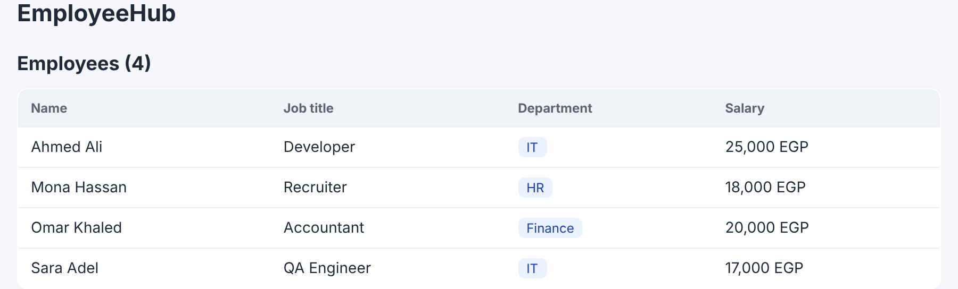
Screen · every employee with the department they work in
A title with the count, and a table: name, job title, department, salary. Nothing to click yet.

The files
File | New or changed | What happens in it
src/api.js | New | getEmployees(): the request, through axios
src/main.jsx | Replace | Starts React inside <div id="root">
src/App.jsx | Replace | The header + the employees page
src/pages/EmployeesPage.jsx | New | Loads the employees and draws the table
src/components/EmployeeRow.jsx | New | One row of the table

The code
client/src/api.js
import axios from 'axios';

// One axios "copy" for the whole app: every request starts with this address.
const api = axios.create({
baseURL: import.meta.env.VITE_API_URL || 'http://localhost:5000/api',
});

// GET http://localhost:5000/api/employees
export async function getEmployees() {
const res = await api.get('/employees');
return res.data; // { items: [...], total, page, pages }
}
Code | What it does / returns
import axios from 'axios' | The library we installed
axios.create({ baseURL }) | An axios copy whose requests all start with http://localhost:5000/api
import.meta.env.VITE_API_URL | Reads client/.env. Only names that start with VITE_ reach the browser
export async function getEmployees() | export: other files can import it · async: it waits for the server
await api.get('/employees') | This is where axios sends the request: GET http://localhost:5000/api/employees
return res.data | The JSON the server sent, already an object: { items, total, page, pages }

client/src/main.jsx
import { StrictMode } from 'react';
import { createRoot } from 'react-dom/client';
import App from './App.jsx';
import './index.css';

createRoot(document.getElementById('root')).render(
<StrictMode>
<App />
</StrictMode>
);
Code | What it does / returns
document.getElementById('root') | index.html has one empty <div id="root">. React builds the whole app inside it
createRoot(...).render(<App />) | Draw the App component there
<StrictMode> | Extra checks in development. It runs effects twice on purpose, so each GET may appear twice in the server terminal
import './index.css' | The styles

client/src/App.jsx
import EmployeesPage from './pages/EmployeesPage';

export default function App() {
return (
<div className="page">
<header className="top">
<span className="brand">EmployeeHub</span>
</header>
<EmployeesPage />
</div>
);
}
App is the root component: the header, then the employees page. className is HTML's class (a reserved word in JavaScript).
client/src/components/EmployeeRow.jsx
// One table row: shows what it receives (the employee prop).
export default function EmployeeRow({ employee }) {
return (
<tr>
<td>{employee.name}</td>
<td>{employee.jobTitle}</td>
{/* department is an object { _id, name } because the API uses populate */}
<td><span className="badge">{employee.department?.name}</span></td>
<td>{employee.salary.toLocaleString()} EGP</td>
</tr>
);
}
Code | What it does / returns
function EmployeeRow({ employee }) | A component. { employee } takes the employee prop the page passes. Like an @Input()
{employee.name} | Prints a value inside JSX. Like {{ }} in Angular
employee.department?.name | Where the department comes from: the server sends department as an object { _id, name } (Session 2: populate). ?. = "if it exists", so a missing department does not crash the page
salary.toLocaleString() | 25000 → 25,000

client/src/pages/EmployeesPage.jsx
import { useEffect, useState } from 'react';
import { getEmployees } from '../api';
import EmployeeRow from '../components/EmployeeRow';

export default function EmployeesPage() {
const [employees, setEmployees] = useState([]); // [] until the server answers
const [total, setTotal] = useState(0);
const [loading, setLoading] = useState(true);
const [error, setError] = useState('');

// Runs ONCE, after the page appears
useEffect(() => {
async function load() {
try {
const data = await getEmployees(); // api.js -> axios -> GET /api/employees
setEmployees(data.items);
setTotal(data.total);
} catch (err) {
setError(err.message); // e.g. "Network Error" when the API is not running
} finally {
setLoading(false);
}
}
load();
}, []);

if (loading) return <p className="muted">Loading…</p>;

return (
<section>
<h2>Employees ({total})</h2>
{error && <p className="error">{error}</p>}
<div className="table-wrap">
<table className="table">
<thead>
<tr><th>Name</th><th>Job title</th><th>Department</th><th>Salary</th></tr>
</thead>
<tbody>
{employees.map((e) => (
<EmployeeRow key={e._id} employee={e} />
))}
</tbody>
</table>
</div>
</section>
);
}
Code | What it does / returns
import { getEmployees } from '../api' | Bring the function from api.js. The page never writes a URL
const [employees, setEmployees] = useState([]) | A box for the list. Starts empty. setEmployees(x) puts x in it and redraws the page
total, loading, error | Three more boxes: the count, "still waiting?", and an error message
useEffect(() => { ... }, []) | "Run this after the page appears, once" ([] = no reason to run again). Like ngOnInit
async function load() | The function inside useEffect cannot be async itself, so we write one inside it and call it
await getEmployees() | Calls api.js → axios → the server. Waits for the answer
setEmployees(data.items) · setTotal(data.total) | Put the answer in the boxes → React redraws → the rows appear
catch (err) → setError(err.message) | Server stopped → "Network Error" shows in red
finally → setLoading(false) | Runs after success or failure: hide "Loading…"
if (loading) return <p>Loading…</p> | While waiting, show only this
{error && <p>...} | &&: show the <p> only if there is an error
employees.map((e) => <EmployeeRow key={e._id} employee={e} />) | One row per employee. key = a unique id so React knows which row is which

Where every function comes from
Function | Written in | Called from | What it does / returns
getEmployees() | api.js | EmployeesPage → load() inside useEffect | Uses axios api.get → GET /api/employees · returns { items, total, page, pages }
api.get() | axios (the library) | getEmployees in api.js | Sends the HTTP request · returns res (res.data = the JSON)
load() | EmployeesPage | useEffect (once, after the first draw) | Calls getEmployees, fills the state
useState / useEffect | React | The top of EmployeesPage | Boxes that redraw · code that runs after drawing
EmployeeRow | components/EmployeeRow.jsx | EmployeesPage → employees.map(...) | Returns one <tr>

The journey
the journey of one action
1. The browser opens http://localhost:5173
2. main.jsx draws <App />, App draws <EmployeesPage />
3. EmployeesPage draws for the first time: loading = true → "Loading…"
4. useEffect runs (after drawing) → load() → getEmployees() [EmployeesPage]
5. getEmployees → api.get('/employees') [api.js → axios]
6. GET http://localhost:5000/api/employees → Express → MongoDB Atlas
7. 200 OK { items: [...], total: 4, ... } → res.data back to the page
8. setEmployees(items), setTotal(4), setLoading(false) [EmployeesPage]
9. React draws again: the title "Employees (4)" + one <EmployeeRow> per employee

Test it

On screen · Open the app
Do | Open http://localhost:5173
You should see | Employees (4) and the table with the department of each employee
Request | GET http://localhost:5000/api/employees
Authorization | None (no token)
Body | No
Response | 200 OK
Response
{ "items": [ { "_id": "...", "name": "Ahmed Ali", "jobTitle": "Developer", "salary": 25000, "department": { "_id": "...", "name": "IT" } }, ... ], "total": 4, "page": 1, "pages": 1 }
F12 → Network → click employees → Response: the same JSON.

On screen · The server is stopped
Do | Ctrl + C in the server terminal, refresh the page
You should see | Red: Network Error
Request | GET http://localhost:5000/api/employees
Authorization | None (no token)
Body | No
Response | No response
Response
(nothing)
Start the server again (npm run dev) and refresh.

Feature 2 · The Departments page and moving between pages

The screens we will build
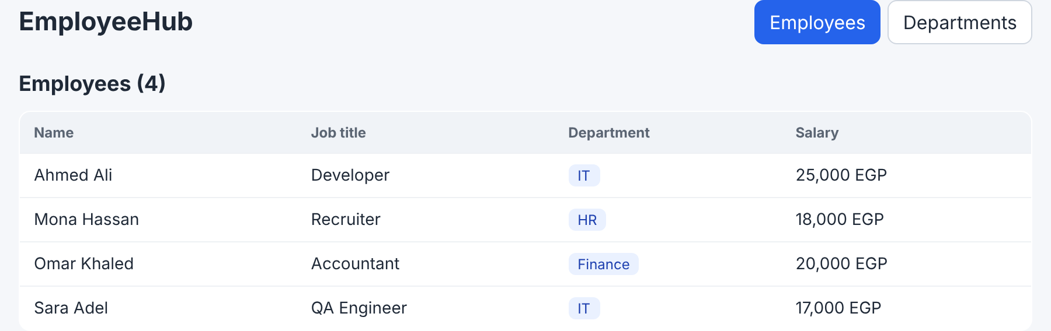
Screen · /employees, now with tabs
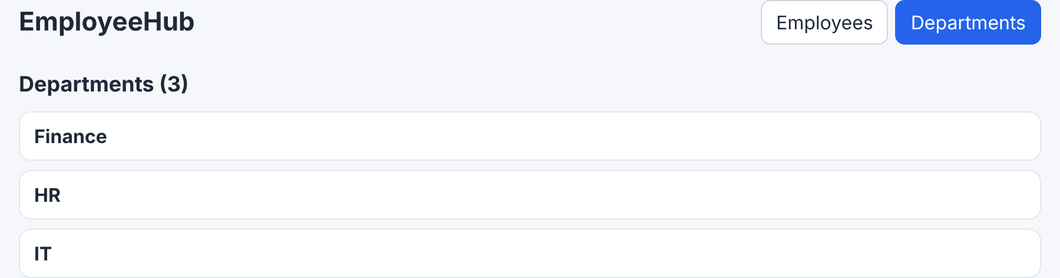
Screen · /departments
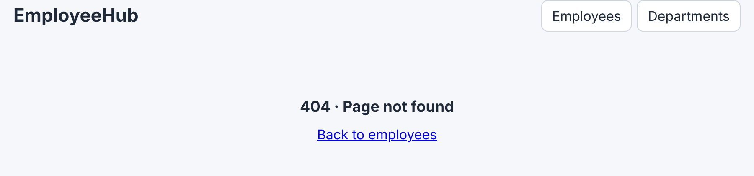
Screen · any other URL
Two tabs at the top. Each page has its own URL, so refresh, Back and links work.

The files
File | New or changed | What happens in it
src/api.js | Changed | + getDepartments()
src/pages/DepartmentsPage.jsx | New | Loads the departments and lists them
src/main.jsx | Changed | Wrapped in <BrowserRouter>
src/App.jsx | Changed | The routes: which URL shows which page
src/components/Navbar.jsx | New | The header with the two tabs
src/pages/NotFoundPage.jsx | New | The 404 page

The code
client/src/api.js
import axios from 'axios';

const api = axios.create({
baseURL: import.meta.env.VITE_API_URL || 'http://localhost:5000/api',
});

// ---------- Departments ----------
// GET http://localhost:5000/api/departments
export async function getDepartments() {
const res = await api.get('/departments');
return res.data; // [ { _id, name }, ... ]
}

// ---------- Employees ----------
export async function getEmployees() {
const res = await api.get('/employees');
return res.data;
}
New: getDepartments(). Same pattern as getEmployees: axios GET /departments, return res.data (an array).
client/src/pages/DepartmentsPage.jsx
import { useEffect, useState } from 'react';
import { getDepartments } from '../api';

export default function DepartmentsPage() {
const [departments, setDepartments] = useState([]);
const [loading, setLoading] = useState(true);
const [error, setError] = useState('');

// Runs ONCE, after the page appears
useEffect(() => {
async function load() {
try {
setDepartments(await getDepartments()); // api.js -> axios -> GET /api/departments
} catch (err) {
setError(err.message);
} finally {
setLoading(false);
}
}
load();
}, []);

if (loading) return <p className="muted">Loading departments…</p>;

return (
<section>
<h2>Departments ({departments.length})</h2>
{error && <p className="error">{error}</p>}
<ul className="list">
{departments.map((d) => (
<li key={d._id} className="item">
<strong>{d.name}</strong>
</li>
))}
</ul>
</section>
);
}
Code | What it does / returns
Same shape as Feature 1 | useState boxes → useEffect(..., []) loads once → draw the list
setDepartments(await getDepartments()) | Wait for the array, then put it in the box
departments.length | The count in the title
departments.map((d) => <li key={d._id}>...) | One line per department

client/src/main.jsx
import { StrictMode } from 'react';
import { createRoot } from 'react-dom/client';
import { BrowserRouter } from 'react-router-dom';
import App from './App.jsx';
import './index.css'; // Vite injects this CSS into the page

// StrictMode = extra checks in development only. It runs effects twice on purpose,
// so you may see every GET request twice in the API terminal. Not in production.
createRoot(document.getElementById('root')).render(
<StrictMode>
<BrowserRouter>
<App />
</BrowserRouter>
</StrictMode>
);
New: <BrowserRouter> around <App />. It lets React Router read and change the URL without reloading the page.
client/src/App.jsx
import { Navigate, Route, Routes } from 'react-router-dom';
import Navbar from './components/Navbar';
import EmployeesPage from './pages/EmployeesPage';
import DepartmentsPage from './pages/DepartmentsPage';
import NotFoundPage from './pages/NotFoundPage';

export default function App() {
return (
<div className="page">
<Navbar />
<Routes>
<Route path="/" element={<Navigate to="/employees" replace />} />
<Route path="/employees" element={<EmployeesPage />} />
<Route path="/departments" element={<DepartmentsPage />} />
<Route path="*" element={<NotFoundPage />} />
</Routes>
</div>
);
}
Code | What it does / returns
<Navbar /> | Outside <Routes>: shown on every page
<Routes> | Looks at the URL and shows the first matching <Route>. Like <router-outlet>
<Route path="/employees" element={<EmployeesPage />} /> | This URL → this page
<Navigate to="/employees" replace /> | A redirect: / → /employees
path="*" | Any URL that matched nothing → 404

client/src/components/Navbar.jsx
// The top bar, shown on every page.
// CONCEPT: NavLink = a link that knows whether its route is active. React Router gives
// className a function: ({ isActive }) => ... so the current page gets the "active" style.
import { Link, NavLink } from 'react-router-dom';

const tab = ({ isActive }) => (isActive ? 'tab active' : 'tab');

export default function Navbar() {
return (
<header className="top">
<Link to="/" className="brand">EmployeeHub</Link>
<nav className="tabs">
<NavLink to="/employees" className={tab}>Employees</NavLink>
<NavLink to="/departments" className={tab}>Departments</NavLink>
</nav>
</header>
);
}
Code | What it does / returns
<Link to="/"> | A link without a page reload (<a href> would reload everything)
<NavLink to="/departments" className={tab}> | A link that knows whether its page is open
const tab = ({ isActive }) => ... | React Router calls it with isActive; the open page gets 'tab active' (blue)

client/src/pages/NotFoundPage.jsx
import { Link } from 'react-router-dom';

// Shown for any URL that matches no route (path="*" in App.jsx).
export default function NotFoundPage() {
return (
<section className="center">
<h2>404 · Page not found</h2>
<Link to="/employees">Back to employees</Link>
</section>
);
}
Why not a useState for the tabs?
useState('employees') can switch pages too, but there is no URL: refresh goes back to the first tab, Back does not work, and you cannot send a link to the departments page.

Where every function comes from
Function | Written in | Called from | What it does / returns
getDepartments() | api.js | DepartmentsPage → load() inside useEffect | axios GET /api/departments · returns [ { _id, name }, ... ]
<BrowserRouter> | react-router-dom | main.jsx | Connects React to the URL
<Routes> / <Route> | react-router-dom | App.jsx | URL → page
<NavLink> / <Link> | react-router-dom | Navbar.jsx, NotFoundPage.jsx | Change the URL without a reload

The journey
the journey of one action
1. Click "Departments" in the Navbar [Navbar → NavLink]
2. React Router changes the URL to /departments (no reload) [BrowserRouter]
3. <Routes> sees /departments → draws <DepartmentsPage /> [App.jsx]
4. useEffect → load() → getDepartments() [DepartmentsPage]
5. api.get('/departments') → GET http://localhost:5000/api/departments [api.js → axios]
6. 200 OK [ { name: "Finance" }, { name: "HR" }, { name: "IT" } ]
7. setDepartments(...) → React draws the list

Test it

On screen · Open the departments page
Do | Click Departments
You should see | The URL becomes /departments · the list of departments · the tab is blue
Request | GET http://localhost:5000/api/departments
Authorization | None (no token)
Body | No
Response | 200 OK
Response
[ { "_id": "...", "name": "Finance" }, { "_id": "...", "name": "HR" }, { "_id": "...", "name": "IT" } ]

On screen · Back, refresh
Do | Press the browser's Back, then F5
You should see | Back returns to /employees · F5 keeps the page you are on
Request | GET http://localhost:5000/api/employees
Authorization | None (no token)
Body | No
Response | 200 OK
Response
{ "items": [ ... ], ... }

On screen · A URL that does not exist
Do | Open http://localhost:5173/abc
You should see | 404 · Page not found
Request | No request: React Router answered

Feature 3 · Search, filter by department, pages

The screens we will build
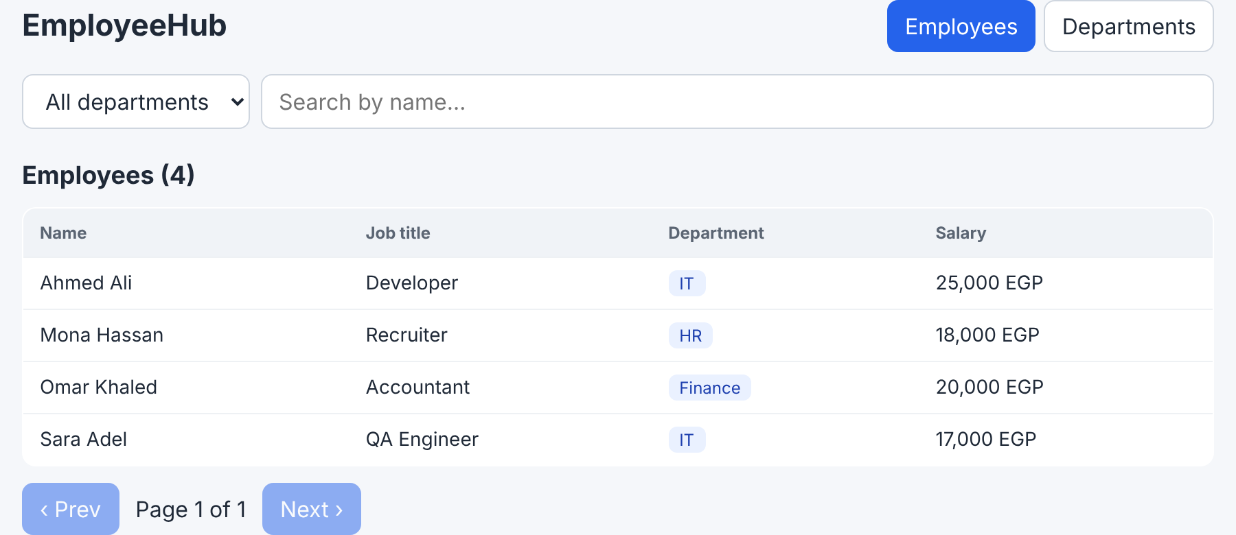
Screen · a dropdown, a search box and a pager
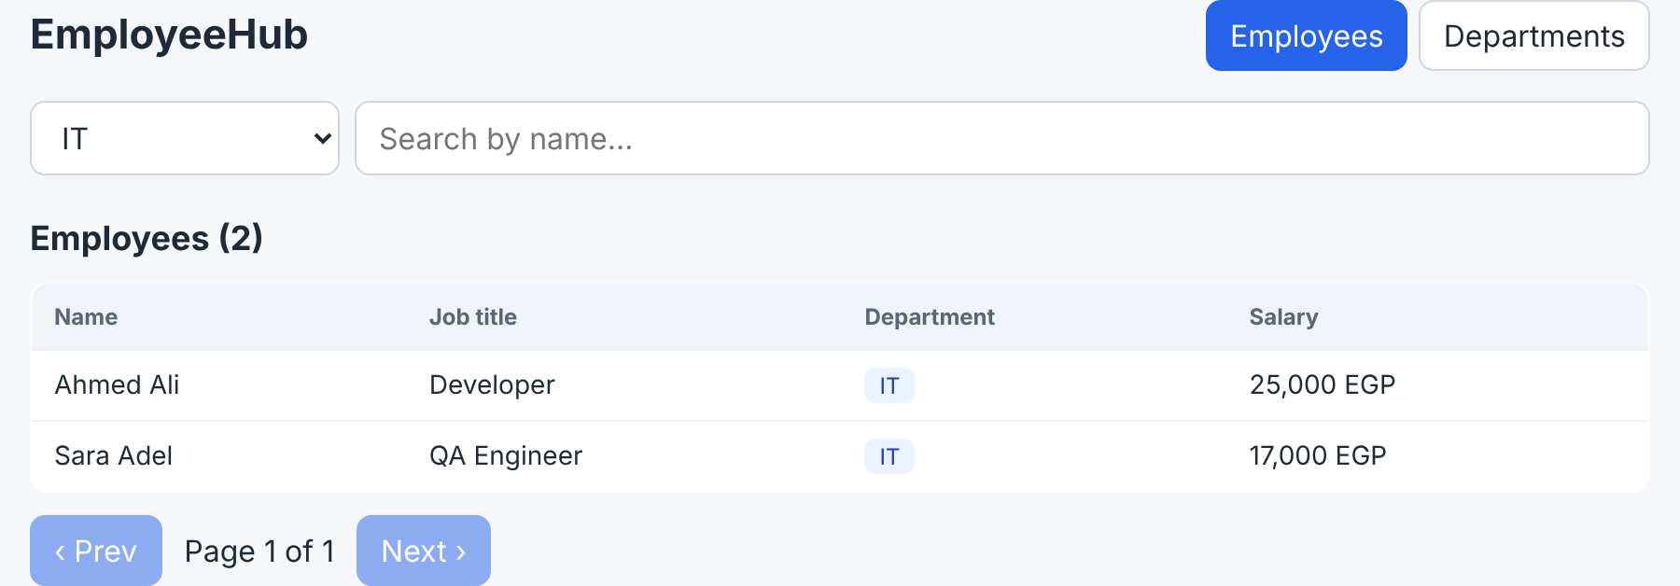
Screen · filter: IT
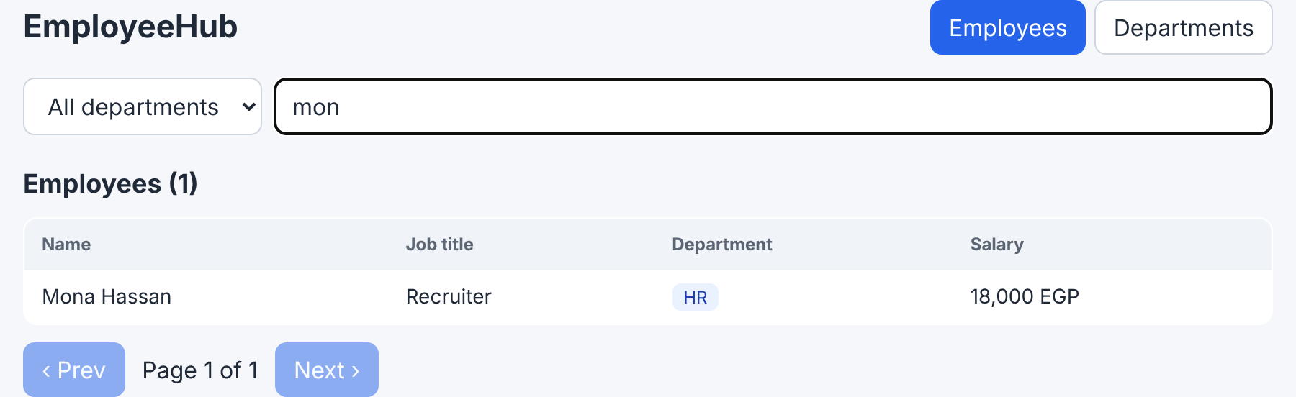
Screen · search: "mon"
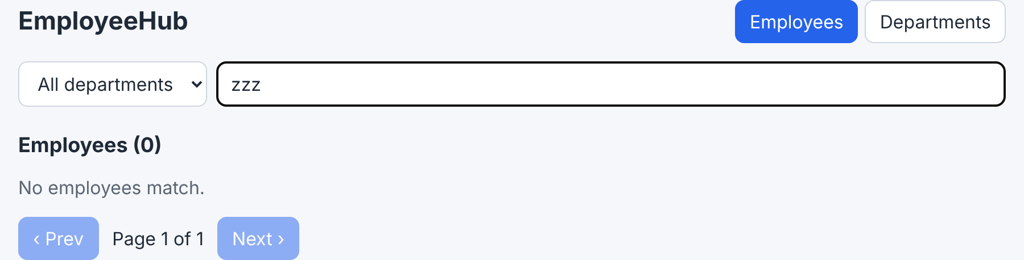
Screen · nothing matches
On the screen | The state behind it | Sent to the server as
All departments dropdown | department (an id, or '' = all) | ?department=<id>
Search by name… | search (every letter) → debouncedSearch (400 ms after typing stops) | ?search=mon
‹ Prev · Page 1 of 1 · Next › | page (what we ask) · pages (what the server says) | ?page=2&limit=5

The big idea: the dropdown, the search box and the buttons only change state. One useEffect watches those values and asks the server again. We never "refresh the table" ourselves. The server does the searching and filtering (Session 2 query parameters).

The files
File | New or changed | What happens in it
src/api.js | Changed | getEmployees(params) now sends query parameters
src/hooks/useDebounce.js | New | Waits until typing stops
src/pages/EmployeesPage.jsx | Changed | Filter, search, pager, and a useEffect that reloads when they change

The code
client/src/api.js
import axios from 'axios';

const api = axios.create({
baseURL: import.meta.env.VITE_API_URL || 'http://localhost:5000/api',
});

// ---------- Departments ----------
export async function getDepartments() {
const res = await api.get('/departments');
return res.data;
}

// ---------- Employees ----------
// params becomes the query string:
// { department: 'x', search: 'mo', page: 1, limit: 5 }
// -> /employees?department=x&search=mo&page=1&limit=5
export async function getEmployees(params) {
const res = await api.get('/employees', { params });
return res.data; // { items, total, page, pages }
}
Code | What it does / returns
getEmployees(params) | Now takes an object, e.g. { department: '', search: 'mon', page: 1, limit: 5 }
api.get('/employees', { params }) | axios builds the query string for us: /employees?department=&search=mon&page=1&limit=5

client/src/hooks/useDebounce.js
import { useEffect, useState } from 'react';

export default function useDebounce(value, delay = 400) {
const [debounced, setDebounced] = useState(value);

useEffect(() => {
const timer = setTimeout(() => setDebounced(value), delay);
return () => clearTimeout(timer); // cleanup: cancel the previous timer
}, [value, delay]);

return debounced;
}
Code | What it does / returns
The problem | Typing mon changes search 3 times: m, mo, mon = 3 requests
useDebounce(value, delay = 400) | A custom hook: a function that starts with use and uses other hooks. Returns value, but only once it stopped changing for 400 ms
useEffect(..., [value, delay]) | Runs every time value changes (every letter)
setTimeout(() => setDebounced(value), delay) | Wait 400 ms, then update debounced
return () => clearTimeout(timer) | Cleanup: before the next run (the next letter), cancel the old timer. Only the last timer survives
return debounced | The settled text

Analogy
A lift does not leave when the first person steps in. It waits until nobody has entered for a few seconds, then moves once.

client/src/pages/EmployeesPage.jsx
import { useEffect, useState } from 'react';
import { getDepartments, getEmployees } from '../api';
import EmployeeRow from '../components/EmployeeRow';
import useDebounce from '../hooks/useDebounce';

const LIMIT = 5; // employees per page

export default function EmployeesPage() {
// What came from the server
const [departments, setDepartments] = useState([]);
const [employees, setEmployees] = useState([]);
const [total, setTotal] = useState(0);
const [pages, setPages] = useState(1);

// What the user chose -> sent to the API as query parameters
const [department, setDepartment] = useState(''); // '' = all
const [search, setSearch] = useState('');
const [page, setPage] = useState(1);
const debouncedSearch = useDebounce(search); // changes 400 ms after the last key press

const [loading, setLoading] = useState(true);
const [error, setError] = useState('');

// Departments: once (for the filter dropdown)
useEffect(() => {
getDepartments()
.then(setDepartments)
.catch((err) => setError(err.message));
}, []);

// Employees: when the page opens AND every time the filter, the search or the page changes
useEffect(() => {
async function loadEmployees() {
setLoading(true);
try {
const data = await getEmployees({ department, search: debouncedSearch, page, limit: LIMIT });
setEmployees(data.items);
setTotal(data.total);
setPages(data.pages || 1);
setError('');
} catch (err) {
setError(err.message);
} finally {
setLoading(false);
}
}
loadEmployees();
}, [department, debouncedSearch, page]);

return (
<section>
<div className="filters">
{/* Changing a filter also goes back to page 1 */}
<select value={department} onChange={(e) => { setDepartment(e.target.value); setPage(1); }}>
<option value="">All departments</option>
{departments.map((d) => (
<option key={d._id} value={d._id}>{d.name}</option>
))}
</select>
<input
placeholder="Search by name…"
value={search}
onChange={(e) => { setSearch(e.target.value); setPage(1); }}
/>
</div>

<h2>Employees ({total})</h2>
{error && <p className="error">{error}</p>}

{loading ? (
<p className="muted">Loading…</p>
) : employees.length === 0 ? (
<p className="muted">No employees match.</p>
) : (
<div className="table-wrap">
<table className="table">
<thead>
<tr><th>Name</th><th>Job title</th><th>Department</th><th>Salary</th></tr>
</thead>
<tbody>
{employees.map((e) => (
<EmployeeRow key={e._id} employee={e} />
))}
</tbody>
</table>
</div>
)}

<div className="pager">
<button disabled={page <= 1} onClick={() => setPage(page - 1)}>‹ Prev</button>
<span>Page {page} of {pages}</span>
<button disabled={page >= pages} onClick={() => setPage(page + 1)}>Next ›</button>
</div>
</section>
);
}
Code | What it does / returns
import { getDepartments, getEmployees } | Two functions from api.js now: the departments fill the dropdown
const LIMIT = 5 | 5 employees per page (a constant, not state: it never changes)
department, search, page | What the user chose
pages | How many pages the server says there are
const debouncedSearch = useDebounce(search) | search changes on every letter; debouncedSearch 400 ms after the last one
First useEffect(..., []) | Once: getDepartments().then(setDepartments) fills the dropdown
Second useEffect(..., [department, debouncedSearch, page]) | Runs when the page opens and every time one of the three changes
getEmployees({ department, search: debouncedSearch, page, limit: LIMIT }) | The object becomes the query string (api.js → axios)
setPages(data.pages || 1) | The server calculates the pages; || 1 when there are no results
<select value={department} onChange={...}> | A controlled input: it shows the state, and changing it updates the state
setDepartment(e.target.value); setPage(1) | e.target.value = the chosen _id. A new filter starts from page 1
departments.map((d) => <option value={d._id}>{d.name}</option>) | The user sees the name; the value sent is the id
<input value={search} onChange={...}> | Every letter → setSearch
loading ? ... : employees.length === 0 ? ... : <table> | Three looks: Loading… / No employees match. / the table
disabled={page <= 1} · setPage(page + 1) | Prev is off on page 1 · Next asks for the next page (the useEffect sees page changed)

Where every function comes from
Function | Written in | Called from | What it does / returns
getEmployees(params) | api.js | The second useEffect in EmployeesPage | axios GET /api/employees?department=&search=&page=&limit= · returns { items, total, page, pages }
getDepartments() | api.js | The first useEffect in EmployeesPage | axios GET /api/departments · fills the dropdown
useDebounce(search) | hooks/useDebounce.js | The top of EmployeesPage | Returns the search text 400 ms after typing stops
setDepartment / setSearch / setPage | React (useState) | onChange of the select and the input · onClick of Prev/Next | Change the state → the useEffect runs → a new request

The journey
the journey of one action
1. The user types "m", "o", "n" quickly in the search box
2. onChange → setSearch("m"), setSearch("mo"), setSearch("mon") [EmployeesPage]
3. useDebounce: each letter cancels the previous timer; 400 ms after "n" → debouncedSearch = "mon"
4. The useEffect sees debouncedSearch changed → getEmployees({ department: '', search: 'mon', page: 1, limit: 5 })
5. axios → GET http://localhost:5000/api/employees?department=&search=mon&page=1&limit=5
6. The server filters in MongoDB → 200 OK { items: [ Mona Hassan ], total: 1, pages: 1 }
7. setEmployees, setTotal, setPages → React draws "Employees (1)" and one row

Test it

On screen · Filter by department
Do | Choose IT in the dropdown
You should see | Only the IT employees · Employees (2)
Request | GET http://localhost:5000/api/employees?department=<IT_ID>&search=&page=1&limit=5
Authorization | None (no token)
Body | No
Response | 200 OK
Response
{ "items": [ Ahmed Ali, Sara Adel ], "total": 2, "page": 1, "pages": 1 }

On screen · Search
Do | All departments · type mon quickly
You should see | Only Mona Hassan · F12 → Network shows ONE search request
Request | GET http://localhost:5000/api/employees?department=&search=mon&page=1&limit=5
Authorization | None (no token)
Body | No
Response | 200 OK
Response
{ "items": [ Mona Hassan ], "total": 1, "page": 1, "pages": 1 }
Verified: three fast letters → one request.

On screen · Nothing matches
Do | Type zzz
You should see | No employees match. · Employees (0)
Request | GET http://localhost:5000/api/employees?department=&search=zzz&page=1&limit=5
Authorization | None (no token)
Body | No
Response | 200 OK
Response
{ "items": [], "total": 0, "page": 1, "pages": 0 }

On screen · Next page
Do | Clear the search · with more than 5 employees click Next ›
You should see | Page 2 of 2
Request | GET http://localhost:5000/api/employees?department=&search=&page=2&limit=5
Authorization | None (no token)
Body | No
Response | 200 OK
Response
{ "items": [ ... ], "page": 2, "pages": 2 }
With 4 employees both buttons stay off. Add a few in Feature 4, or test with limit 2.

Feature 4 · Add, edit and delete employees

The screens we will build
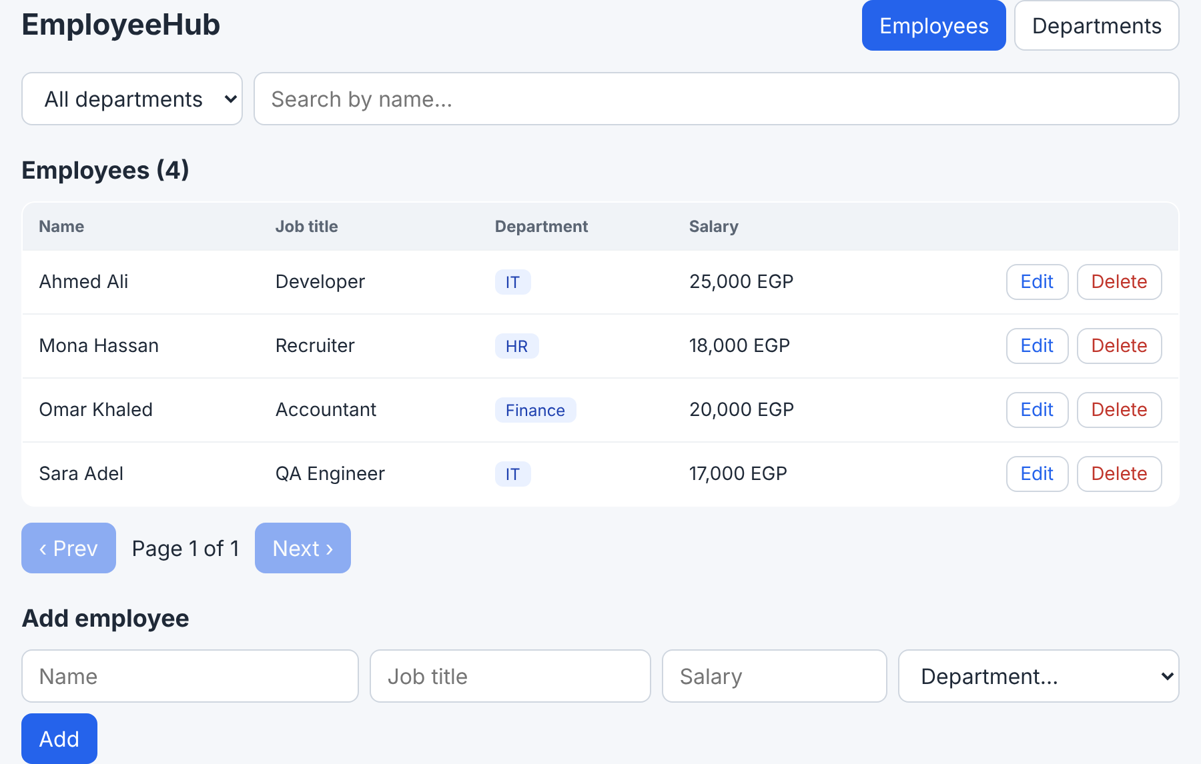
Screen · Edit and Delete in every row · the Add employee form
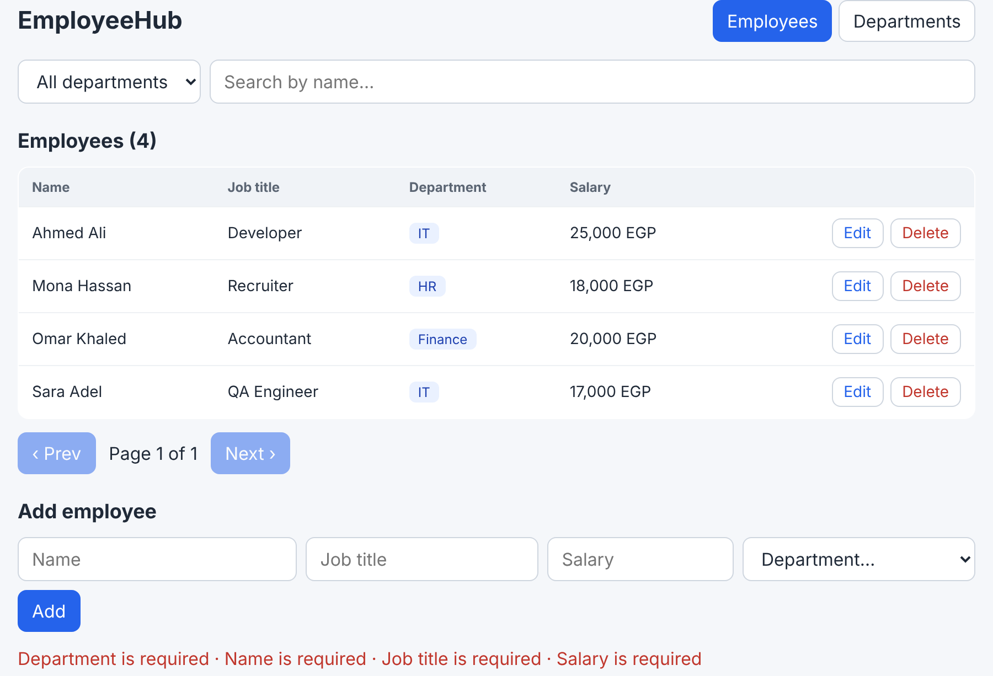
Screen · Add with empty inputs: the server's messages
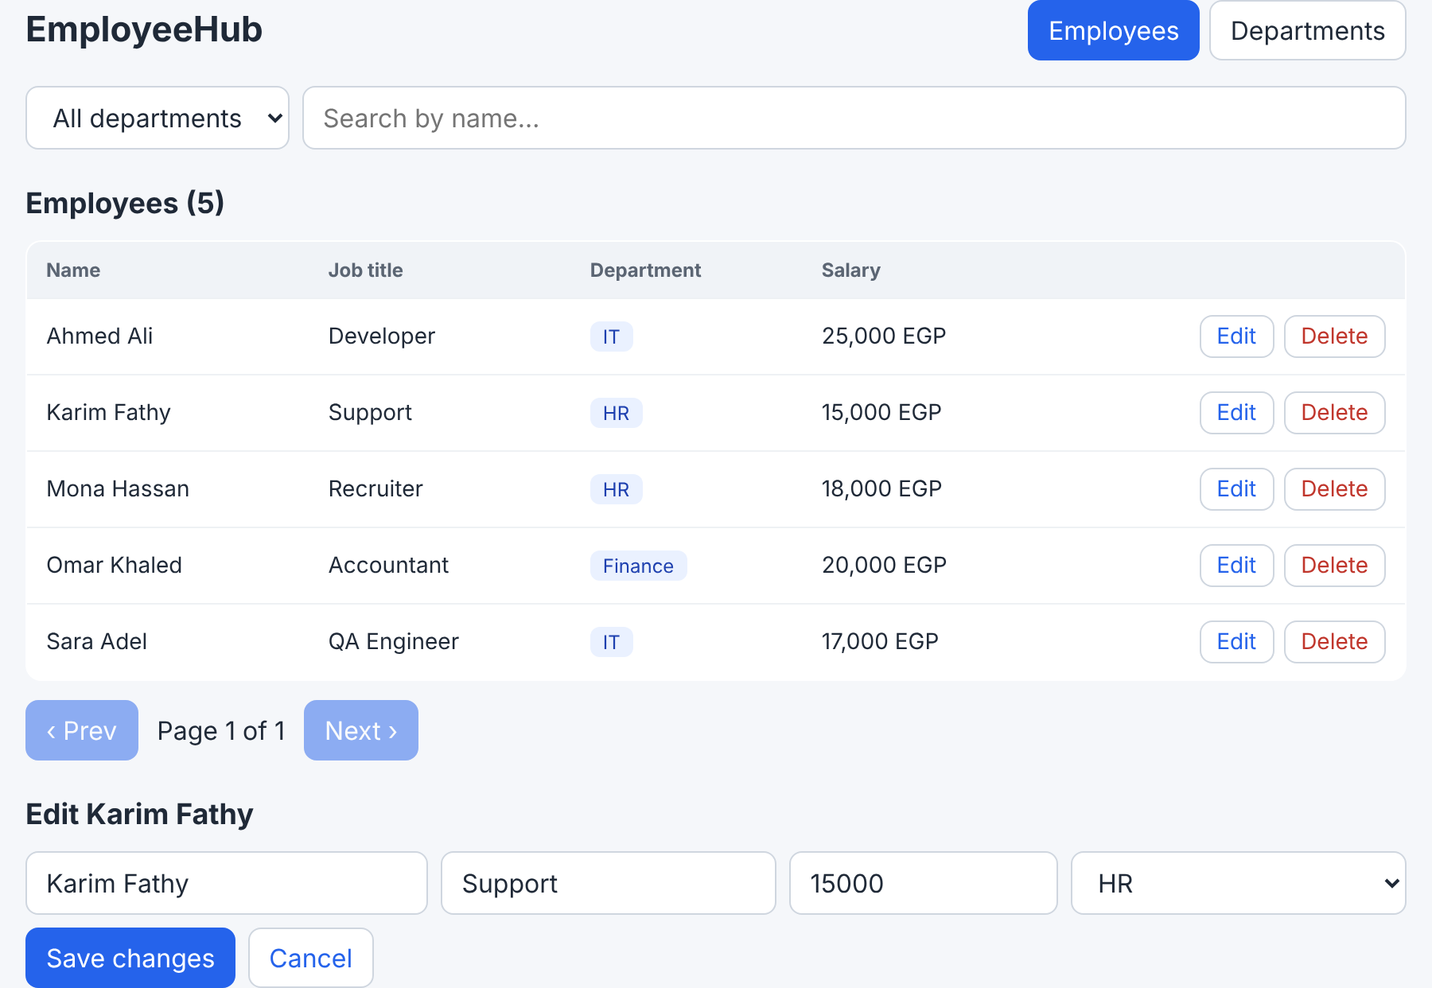
Screen · after Edit: the same form, filled
On the screen | Comes from
Edit / Delete in a row | EmployeeRow calls onEdit / onDelete, functions the page passed to it
Add employee / Edit Karim Fathy | editing in the page: null = add · an employee = edit
The four inputs | form state inside EmployeeForm
Add / Save changes + Cancel | The initial prop: null → Add · an employee → Save changes + Cancel
The red line | error: the server's messages, joined by getErrorMessage

The files
File | New or changed | What happens in it
src/api.js | Changed | + createEmployee, updateEmployee, deleteEmployee, getErrorMessage
src/components/EmployeeForm.jsx | New | One form for add and edit
src/components/EmployeeRow.jsx | Changed | + the Edit and Delete buttons
src/pages/EmployeesPage.jsx | Changed | + editing, handleSave, handleDelete, the form · loadEmployees moves out of the useEffect

The code
client/src/api.js (the full file: Feature 5 uses the department functions)
import axios from 'axios';

// import.meta.env = Vite's version of process.env. Only VITE_ variables reach the browser.
const api = axios.create({
baseURL: import.meta.env.VITE_API_URL || 'http://localhost:5000/api',
});

// ---------- Departments ----------
export async function getDepartments() {
const res = await api.get('/departments'); // GET http://localhost:5000/api/departments
return res.data; // [ { _id, name, ... }, ... ]
}

export async function createDepartment(data) {
const res = await api.post('/departments', data); // body: { name }
return res.data; // the new department (with its _id)
}

export async function updateDepartment(id, data) {
const res = await api.put(`/departments/${id}`, data);
return res.data; // the department AFTER the update
}

export async function deleteDepartment(id) {
await api.delete(`/departments/${id}`); // 204: nothing to return
}

// ---------- Employees ----------
// params becomes the query string: { department: 'x', search: 'a', page: 1, limit: 5 }
// -> /employees?department=x&search=a&page=1&limit=5
export async function getEmployees(params) {
const res = await api.get('/employees', { params });
return res.data; // { items, total, page, pages }
}

export async function createEmployee(data) {
const res = await api.post('/employees', data);
return res.data;
}

export async function updateEmployee(id, data) {
const res = await api.put(`/employees/${id}`, data);
return res.data;
}

export async function deleteEmployee(id) {
await api.delete(`/employees/${id}`);
}

// Turns any axios error into one readable sentence for the screen.
// 400 validation -> "Name must be at least 3 characters · Salary must be at least 1000"
// 409 / 404 -> the server's message
// server down -> "Network Error"
export function getErrorMessage(err) {
const data = err.response?.data; // undefined when the server did not answer at all
if (data?.errors) return data.errors.join(' · ');
if (data?.message) return data.message;
if (err.request && !err.response) return 'Cannot reach the server. Is the API running?';
return err.message;
}

// The axios instance itself (for one-off requests, e.g. the lab).
export default api;
Code | What it does / returns
createEmployee(data) | axios POST /employees with data as the JSON body · returns the new employee
updateEmployee(id, data) | axios PUT /employees/<id> · returns the employee after the change
deleteEmployee(id) | axios DELETE /employees/<id> · the server answers 204 (nothing to return)
` /employees/${id} ` | A template string: puts the id inside the URL. Like $"/employees/{id}" in C#
getErrorMessage(err) | Turns any axios error into one sentence for the screen
err.response?.data | The server's error JSON. No response = the server did not answer
data.errors.join(' · ') | A 400 validation error: ["Name is required", ...] → one line
export default api | The axios copy itself (used in the lab)

Why axios throws
axios throws for 400/404/409/500. So every page uses one try { await ... } catch (err) { setError(getErrorMessage(err)) } and the message appears in red.

client/src/components/EmployeeRow.jsx
export default function EmployeeRow({ employee, onEdit, onDelete }) {
return (
<tr>
<td>{employee.name}</td>
<td>{employee.jobTitle}</td>
{/* department is an object because the API uses populate('department', 'name') */}
<td><span className="badge">{employee.department?.name}</span></td>
{/* toLocaleString adds thousands separators: 25000 -> 25,000 */}
<td>{employee.salary.toLocaleString()} EGP</td>
<td>
<div className="actions">
<button className="ghost" onClick={() => onEdit(employee)}>Edit</button>
<button className="ghost danger" onClick={() => onDelete(employee)}>Delete</button>
</div>
</td>
</tr>
);
}
Code | What it does / returns
{ employee, onEdit, onDelete } | onEdit and onDelete are functions the page passes in. Like @Output()
onClick={() => onEdit(employee)} | On click, tell the page "edit this one". The row itself never calls the API
Why () => | onClick={onDelete(employee)} would run while drawing, deleting everyone when the page opens

client/src/components/EmployeeForm.jsx
import { useState } from 'react';
import { getErrorMessage } from '../api';

const empty = { name: '', jobTitle: '', salary: '', department: '' };

// The API returns department as an object { _id, name }; the <select> needs only the _id.
function toForm(employee) {
if (!employee) return empty;
return {
name: employee.name,
jobTitle: employee.jobTitle,
salary: String(employee.salary),
department: employee.department?._id || '',
};
}

export default function EmployeeForm({ departments, initial, onSave, onCancel }) {
const [form, setForm] = useState(toForm(initial));
const [error, setError] = useState('');
const [saving, setSaving] = useState(false);

// One handler for every input, thanks to the name attribute:
// the input with name="salary" updates form.salary
function handleChange(e) {
setForm({ ...form, [e.target.name]: e.target.value });
}

async function handleSubmit(e) {
e.preventDefault();
setSaving(true);
try {
// Inputs always give strings. Empty values -> undefined, so the server says "... is required"
// ('' is not a valid ObjectId: Mongoose would answer "Cast to ObjectId failed" instead).
await onSave({
...form,
salary: form.salary === '' ? undefined : Number(form.salary),
department: form.department || undefined,
});
if (!initial) setForm(empty); // after adding, clear the form
setError('');
} catch (err) {
// The SERVER validates (Mongoose schema) and we just show its messages:
// "Job title is required · Name must be at least 3 characters · Salary must be at least 1000"
setError(getErrorMessage(err));
} finally {
setSaving(false);
}
}

return (
<form className="form" onSubmit={handleSubmit}>
<input name="name" placeholder="Name" value={form.name} onChange={handleChange} />
<input name="jobTitle" placeholder="Job title" value={form.jobTitle} onChange={handleChange} />
<input name="salary" type="number" placeholder="Salary" value={form.salary} onChange={handleChange} />
<select name="department" value={form.department} onChange={handleChange}>
<option value="">Department…</option>
{departments.map((d) => (
<option key={d._id} value={d._id}>{d.name}</option>
))}
</select>
<div className="form-actions">
<button type="submit" disabled={saving}>{initial ? 'Save changes' : 'Add'}</button>
{initial && <button type="button" className="ghost" onClick={onCancel}>Cancel</button>}
</div>
{error && <p className="error">{error}</p>}
</form>
);
}
Code | What it does / returns
toForm(employee) | null → empty inputs · an employee → its values. department becomes just the _id (the dropdown needs an id)
useState(toForm(initial)) | The inputs' values live in state: a controlled form
value={form.name} + onChange={handleChange} | The input shows the state; every key press updates it. Like [(ngModel)]
setForm({ ...form, [e.target.name]: e.target.value }) | A copy of the form with one field changed. name="salary" updates form.salary, so one function serves every input
e.preventDefault() | Stops the browser reloading the page on submit
Number(form.salary) | Inputs always give strings
department: form.department || undefined | Not chosen → send nothing, so the server says "Department is required"
await onSave(...) | The form does not call the API. It calls onSave, a function the page passed in. The page does POST or PUT
catch → setError(getErrorMessage(err)) | If the server says 400, the messages appear under the form
if (!initial) setForm(empty) | After adding, clear the inputs

client/src/pages/EmployeesPage.jsx
import { useEffect, useState } from 'react';
import { getDepartments, getEmployees, createEmployee, updateEmployee, deleteEmployee, getErrorMessage } from '../api';
import EmployeeRow from '../components/EmployeeRow';
import EmployeeForm from '../components/EmployeeForm';
import useDebounce from '../hooks/useDebounce';

const LIMIT = 5; // employees per page

export default function EmployeesPage() {
const [departments, setDepartments] = useState([]);
const [employees, setEmployees] = useState([]);
const [total, setTotal] = useState(0);
const [pages, setPages] = useState(1);

// What the user chose -> sent to the API as query parameters
const [department, setDepartment] = useState(''); // '' = all
const [search, setSearch] = useState('');
const [page, setPage] = useState(1);

// The request uses the DEBOUNCED text: it changes 400 ms after the last key press
const debouncedSearch = useDebounce(search);

const [editing, setEditing] = useState(null); // the employee being edited, or null = "add" mode
const [loading, setLoading] = useState(true);
const [error, setError] = useState('');

// Departments: once (for the filter and the form's dropdown)
useEffect(() => {
getDepartments()
.then(setDepartments)
.catch((err) => setError(getErrorMessage(err)));
}, []);

// Employees: every time the filter, the search or the page changes
async function loadEmployees() {
setLoading(true);
try {
const data = await getEmployees({ department, search: debouncedSearch, page, limit: LIMIT });
setEmployees(data.items);
setTotal(data.total);
setPages(data.pages || 1);
setError('');
} catch (err) {
setError(getErrorMessage(err));
} finally {
setLoading(false);
}
}

useEffect(() => {
loadEmployees();
}, [department, debouncedSearch, page]); // eslint-disable-line react-hooks/exhaustive-deps

// CREATE or UPDATE. EmployeeForm calls this; if it throws, the form shows the error.
async function handleSave(data) {
if (editing) {
await updateEmployee(editing._id, data);
setEditing(null); // back to "add" mode
} else {
await createEmployee(data);
}
await loadEmployees(); // ask the server again: the list, total and pages stay correct
}

// DELETE
async function handleDelete(employee) {
if (!window.confirm(`Delete ${employee.name}?`)) return;
try {
await deleteEmployee(employee._id);
if (editing?._id === employee._id) setEditing(null);
await loadEmployees();
} catch (err) {
setError(getErrorMessage(err));
}
}

return (
<section>
<div className="filters">
{/* Changing a filter also goes back to page 1 */}
<select value={department} onChange={(e) => { setDepartment(e.target.value); setPage(1); }}>
<option value="">All departments</option>
{departments.map((d) => (
<option key={d._id} value={d._id}>{d.name}</option>
))}
</select>
<input
placeholder="Search by name…"
value={search}
onChange={(e) => { setSearch(e.target.value); setPage(1); }}
/>
</div>

<h2>Employees ({total})</h2>
{error && <p className="error">{error}</p>}

{loading ? (
<p className="muted">Loading…</p>
) : employees.length === 0 ? (
<p className="muted">No employees match.</p>
) : (
<div className="table-wrap">
<table className="table">
<thead>
<tr><th>Name</th><th>Job title</th><th>Department</th><th>Salary</th><th></th></tr>
</thead>
<tbody>
{employees.map((e) => (
<EmployeeRow key={e._id} employee={e} onEdit={setEditing} onDelete={handleDelete} />
))}
</tbody>
</table>
</div>
)}

<div className="pager">
<button disabled={page <= 1} onClick={() => setPage(page - 1)}>‹ Prev</button>
<span>Page {page} of {pages}</span>
<button disabled={page >= pages} onClick={() => setPage(page + 1)}>Next ›</button>
</div>

<h2>{editing ? `Edit ${editing.name}` : 'Add employee'}</h2>
{/* CONCEPT: key resets a component. A new key = React throws the old form away and
creates a fresh one, so the inputs are filled with the employee we clicked. */}
<EmployeeForm
key={editing?._id || 'new'}
departments={departments}
initial={editing}
onSave={handleSave}
onCancel={() => setEditing(null)}
/>
</section>
);
}
Code | What it does / returns
editing | null = the form adds · an employee = the form edits that one
async function loadEmployees() outside the useEffect | Moved out so handleSave and handleDelete can call it too, to reload the list after a change
useEffect(() => { loadEmployees(); }, [department, debouncedSearch, page]) | Same job as Feature 3
handleSave(data) | Called by EmployeeForm. editing ? updateEmployee : createEmployee, then loadEmployees() so the count and pages stay right
handleDelete(employee) | Called by EmployeeRow. window.confirm → deleteEmployee → loadEmployees()
<EmployeeRow ... onEdit={setEditing} onDelete={handleDelete} /> | Edit just puts the employee in editing; Delete runs handleDelete
<EmployeeForm key={editing?._id || 'new'} initial={editing} onSave={handleSave} .../> | A new key makes React create a fresh form, filled with the clicked employee
getErrorMessage(err) | Replaces err.message everywhere: readable messages

Where every function comes from
Function | Written in | Called from | What it does / returns
createEmployee(data) | api.js | handleSave in EmployeesPage (when editing is null) | axios POST /api/employees · 201 + the employee
updateEmployee(id, data) | api.js | handleSave (when editing is an employee) | axios PUT /api/employees/:id · 200 + the employee
deleteEmployee(id) | api.js | handleDelete in EmployeesPage | axios DELETE /api/employees/:id · 204
handleSave(data) | EmployeesPage | EmployeeForm → onSave(...) in handleSubmit | POST or PUT, then reload
handleDelete(employee) | EmployeesPage | EmployeeRow → onDelete(employee) on click | Confirm, DELETE, reload
setEditing(employee) | React (useState) | EmployeeRow → onEdit(employee) on click | Switches the form to edit mode
loadEmployees() | EmployeesPage | The useEffect, handleSave, handleDelete | axios GET (through getEmployees) and fills the table
getErrorMessage(err) | api.js | Every catch in the pages and the form | Returns one readable sentence

The journey of "Add"
the journey of one action
1. The user fills the form and clicks Add
2. EmployeeForm.handleSubmit: preventDefault → onSave({ name, jobTitle, salary: 15000, department: id }) [EmployeeForm]
3. onSave IS handleSave in the page → editing is null → createEmployee(data) [EmployeesPage]
4. createEmployee → api.post('/employees', data) [api.js → axios]
5. POST http://localhost:5000/api/employees → Mongoose validates → Atlas saves
6. 201 Created { _id, name: "Karim Fathy", ... }
7. handleSave → await loadEmployees() → GET /api/employees?... → setEmployees → the new row appears
8. Back in EmployeeForm: setForm(empty) → the inputs are cleared

If the server says 400 at step 5: axios throws → it leaves handleSave → EmployeeForm's catch
→ setError(getErrorMessage(err)) → the red messages appear, the inputs stay.

Test it

On screen · Add with empty inputs
Do | Click Add with nothing typed
You should see | Red: Department is required · Name is required · Job title is required · Salary is required
Request | POST http://localhost:5000/api/employees
Authorization | None (no token)
Body | Yes, JSON (below)
Response | 400 Bad Request
Body
{ "name": "", "jobTitle": "" }
Response
{ "message": "Validation failed", "errors": [ "Department is required", "Name is required", "Job title is required", "Salary is required" ] }

On screen · Add an employee
Do | Karim Fathy · Support · 15000 · HR → Add
You should see | Karim Fathy appears · Employees (5) · the inputs are cleared
Request | POST http://localhost:5000/api/employees
Authorization | None (no token)
Body | Yes, JSON (below)
Response | 201 Created
Body
{
"name": "Karim Fathy",
"jobTitle": "Support",
"salary": 15000,
"department": "<HR_ID>"
}
Response
{ "_id": "...", "name": "Karim Fathy", "department": { "_id": "...", "name": "HR" }, ... }
F12 → Network → the request → Payload shows this body.
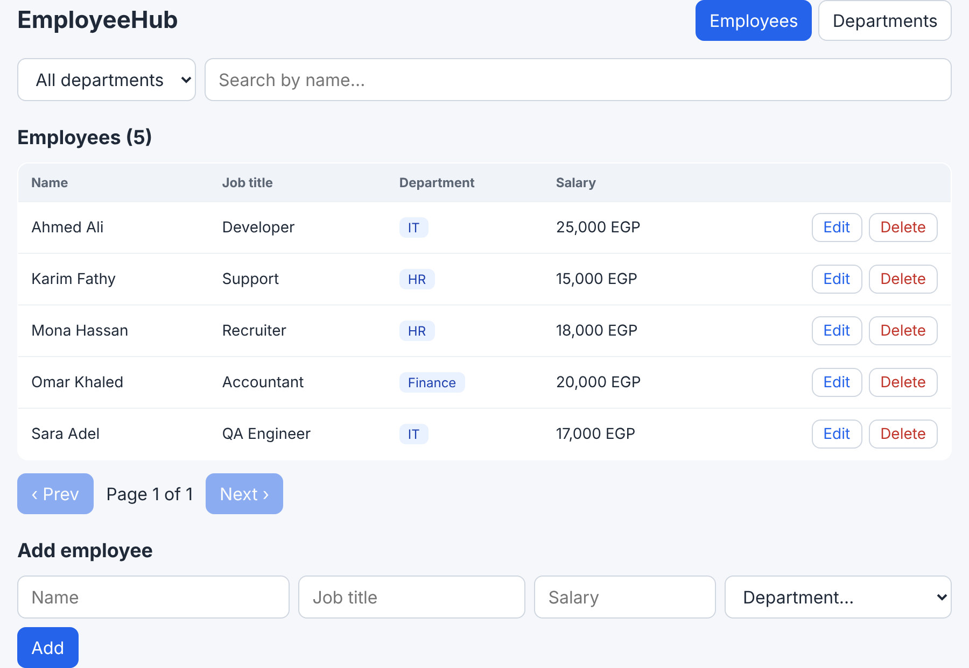
Screen · after Add

On screen · Edit
Do | Edit next to Karim Fathy · Job title Senior Support · Save changes
You should see | The row shows Senior Support · the form goes back to "Add employee"
Request | PUT http://localhost:5000/api/employees/<KARIM_ID>
Authorization | None (no token)
Body | Yes, JSON (below)
Response | 200 OK
Body
{
"name": "Karim Fathy",
"jobTitle": "Senior Support",
"salary": 15000,
"department": "<HR_ID>"
}
Response
{ "_id": "...", "jobTitle": "Senior Support", ... }
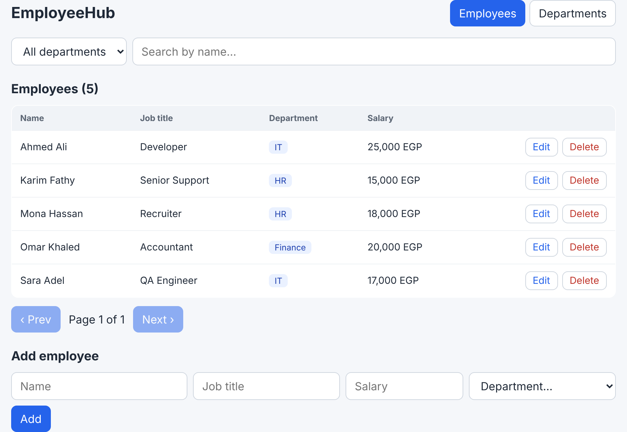
Screen · after Save changes

On screen · Delete
Do | Delete next to Karim Fathy · OK
You should see | The row disappears · Employees (4)
Request | DELETE http://localhost:5000/api/employees/<KARIM_ID>
Authorization | None (no token)
Body | No
Response | 204 No Content
Response
(empty)

Feature 5 · Add, rename and delete departments

The screens we will build
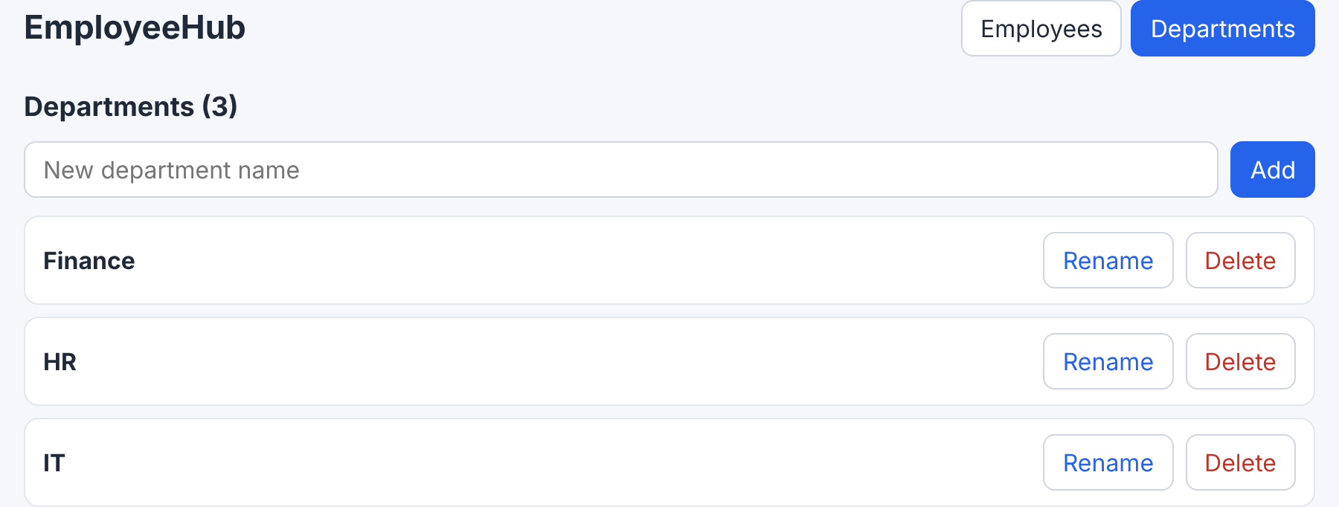
Screen · an Add box, and Rename / Delete on every line
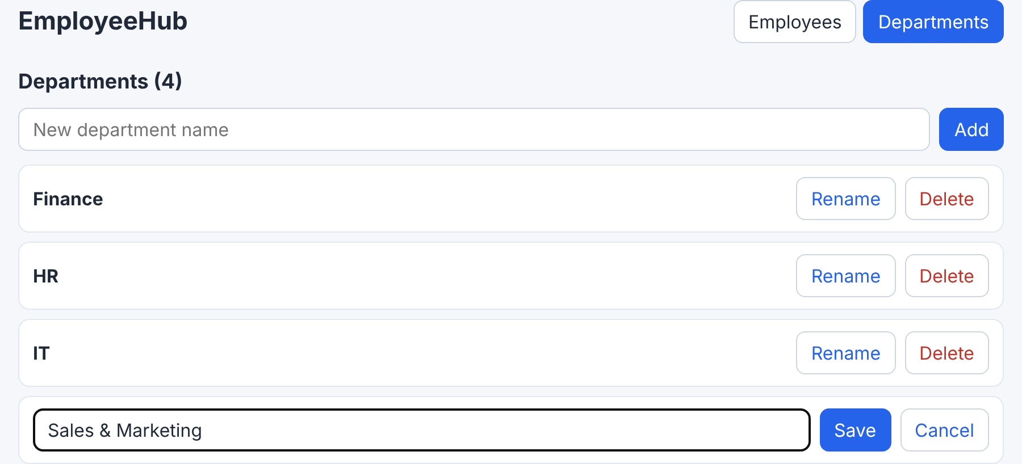
Screen · after Rename: an input with Save / Cancel
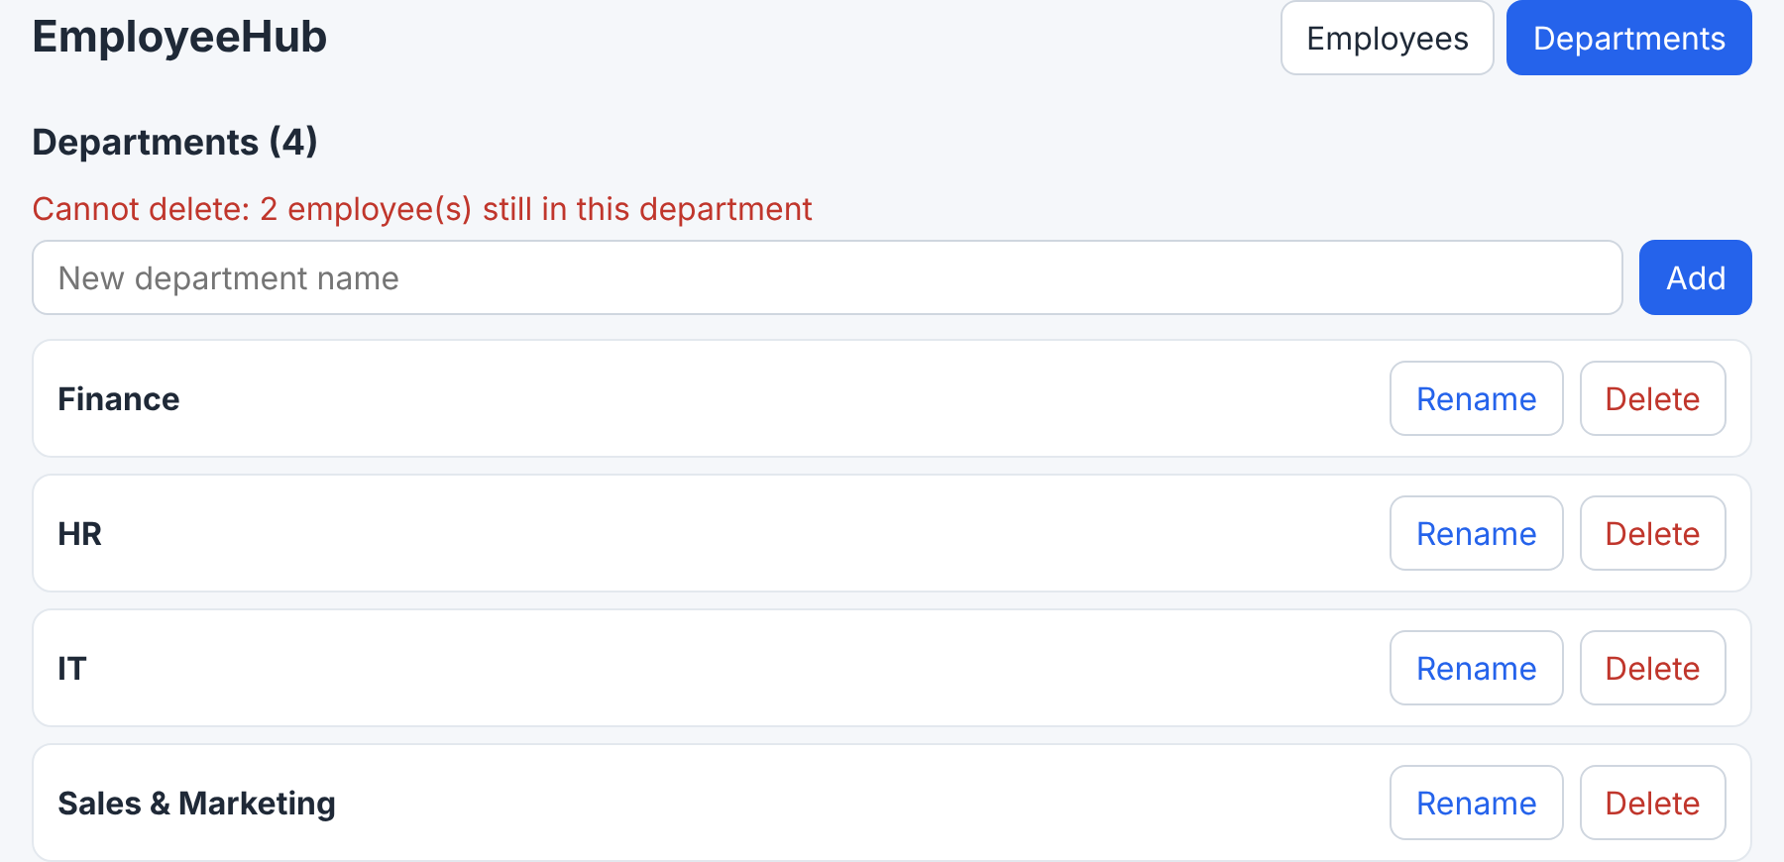
Screen · Delete a department that still has employees
On the screen | Comes from
New department name + Add | name state + handleAdd in the page
Each line with Rename / Delete | One DepartmentItem per department
The input with Save / Cancel | editing state inside that one DepartmentItem
The red line | 400 empty name · 409 duplicate · 409 still has employees

The files
File | New or changed | What happens in it
src/api.js | Already done | createDepartment, updateDepartment, deleteDepartment (in the full file from Feature 4)
src/components/DepartmentItem.jsx | New | One line, with its own edit mode
src/pages/DepartmentsPage.jsx | Changed | + the Add form, handleAdd, handleRename, handleDelete

The code
client/src/components/DepartmentItem.jsx
import { useState } from 'react';
import { getErrorMessage } from '../api';

export default function DepartmentItem({ department, onRename, onDelete }) {
const [editing, setEditing] = useState(false);
const [name, setName] = useState(department.name);
const [error, setError] = useState('');

async function handleSave() {
try {
await onRename(department._id, name); // the parent calls the API and updates the list
setEditing(false);
setError('');
} catch (err) {
setError(getErrorMessage(err)); // empty name -> 400, duplicate -> 409
}
}

function handleCancel() {
setName(department.name); // throw away what was typed
setEditing(false);
setError('');
}

// Two different looks for the same item, chosen by state
if (editing) {
return (
<li className="item">
<input value={name} onChange={(e) => setName(e.target.value)} autoFocus />
<button onClick={handleSave}>Save</button>
<button className="ghost" onClick={handleCancel}>Cancel</button>
{error && <p className="error">{error}</p>}
</li>
);
}

return (
<li className="item">
<strong>{department.name}</strong>
<button className="ghost" onClick={() => setEditing(true)}>Rename</button>
{/* An arrow function: onDelete runs on click, not during render */}
<button className="ghost danger" onClick={() => onDelete(department)}>Delete</button>
</li>
);
}
Code | What it does / returns
useState(false) for editing | Local state: only this line needs to know it is being edited
await onRename(department._id, name) | Calls the page's handleRename (a prop). The item does not call the API
catch → setError(...) | A 400/409 shows under this line only
handleCancel() | Puts the old name back and leaves edit mode
if (editing) return (...) / return (...) | Two looks for the same item, chosen by state

client/src/pages/DepartmentsPage.jsx
import { useEffect, useState } from 'react';
import { getDepartments, createDepartment, updateDepartment, deleteDepartment, getErrorMessage } from '../api';
import DepartmentItem from '../components/DepartmentItem';

export default function DepartmentsPage() {
const [departments, setDepartments] = useState([]); // [] until the server answers
const [name, setName] = useState(''); // the "new department" input
const [loading, setLoading] = useState(true);
const [error, setError] = useState('');

// Load once when the page opens
useEffect(() => {
async function load() {
try {
setDepartments(await getDepartments());
} catch (err) {
setError(getErrorMessage(err)); // e.g. "Network Error" when the API is not running
} finally {
setLoading(false); // runs after success OR failure
}
}
load();
}, []);

// CREATE
async function handleAdd(e) {
e.preventDefault(); // stop the browser from reloading the page
try {
const created = await createDepartment({ name });
setDepartments([...departments, created]); // a NEW array (never push)
setName('');
setError('');
} catch (err) {
setError(getErrorMessage(err)); // 400 empty name, 409 duplicate
}
}

// UPDATE: DepartmentItem calls this with the new name
async function handleRename(id, newName) {
const updated = await updateDepartment(id, { name: newName });
// map() returns a NEW array: the changed department is replaced, the others stay
setDepartments(departments.map((d) => (d._id === id ? updated : d)));
}

// DELETE
async function handleDelete(department) {
if (!window.confirm(`Delete ${department.name}?`)) return;
try {
await deleteDepartment(department._id);
setDepartments(departments.filter((d) => d._id !== department._id));
setError('');
} catch (err) {
setError(getErrorMessage(err)); // 409 "Cannot delete: 2 employee(s) still in this department"
}
}

if (loading) return <p className="muted">Loading departments…</p>;

return (
<section>
<h2>Departments ({departments.length})</h2>
{error && <p className="error">{error}</p>}

<form className="row-form" onSubmit={handleAdd}>
<input placeholder="New department name" value={name} onChange={(e) => setName(e.target.value)} />
<button type="submit">Add</button>
</form>

<ul className="list">
{departments.map((d) => (
<DepartmentItem key={d._id} department={d} onRename={handleRename} onDelete={handleDelete} />
))}
</ul>
</section>
);
}
Code | What it does / returns
handleAdd(e) | createDepartment({ name }) → setDepartments([...departments, created])
[...departments, created] | A new array: the old items + the new one. push would change the old array and React would not redraw
handleRename(id, newName) | updateDepartment → departments.map((d) => d._id === id ? updated : d): a new array with that one replaced
handleDelete(department) | deleteDepartment → departments.filter((d) => d._id !== department._id): a new array without it
Why no reload here (unlike employees) | The departments list has no pages and no filter, so updating the array ourselves is safe and faster

Where every function comes from
Function | Written in | Called from | What it does / returns
createDepartment({ name }) | api.js | handleAdd (the form's onSubmit) | axios POST /api/departments · 201 + the department
updateDepartment(id, { name }) | api.js | handleRename ← DepartmentItem.handleSave → onRename | axios PUT /api/departments/:id · 200
deleteDepartment(id) | api.js | handleDelete ← the Delete button in DepartmentItem → onDelete | axios DELETE /api/departments/:id · 204 or 409

The journey of "Rename"
the journey of one action
1. Click Rename on Sales → DepartmentItem: setEditing(true) → an input appears [DepartmentItem]
2. Type "Sales & Marketing" → Save → handleSave → onRename(id, name)
3. onRename IS handleRename in the page → updateDepartment(id, { name }) [DepartmentsPage]
4. api.put('/departments/<id>', { name }) → PUT http://localhost:5000/api/departments/<id> [api.js → axios]
5. 200 OK { _id, name: "Sales & Marketing" }
6. setDepartments(departments.map(...)) → React redraws the list with the new name
7. Back in DepartmentItem: setEditing(false) → the line goes back to normal

Test it

On screen · Add a duplicate
Do | Type HR → Add
You should see | Red: name "HR" already exists
Request | POST http://localhost:5000/api/departments
Authorization | None (no token)
Body | Yes, JSON (below)
Response | 409 Conflict
Body
{ "name": "HR" }
Response
{ "message": "name \"HR\" already exists" }

On screen · Add
Do | Type Sales → Add
You should see | Sales appears · Departments (4)
Request | POST http://localhost:5000/api/departments
Authorization | None (no token)
Body | Yes, JSON (below)
Response | 201 Created
Body
{ "name": "Sales" }
Response
{ "_id": "...", "name": "Sales" }

On screen · Rename
Do | Rename next to Sales · Sales & Marketing · Save
You should see | The new name
Request | PUT http://localhost:5000/api/departments/<SALES_ID>
Authorization | None (no token)
Body | Yes, JSON (below)
Response | 200 OK
Body
{ "name": "Sales & Marketing" }
Response
{ "_id": "...", "name": "Sales & Marketing" }
Empty name → 400 under that line.

On screen · Delete one that has employees
Do | Delete next to IT · OK
You should see | Red: Cannot delete: 2 employee(s) still in this department · IT stays
Request | DELETE http://localhost:5000/api/departments/<IT_ID>
Authorization | None (no token)
Body | No
Response | 409 Conflict
Response
{ "message": "Cannot delete: 2 employee(s) still in this department" }

On screen · Delete an empty one
Do | Delete next to Sales & Marketing · OK
You should see | It disappears
Request | DELETE http://localhost:5000/api/departments/<SALES_ID>
Authorization | None (no token)
Body | No
Response | 204 No Content
Response
(empty)

Feature 6 · Final check, lab and troubleshooting

The whole map
Page / component | Calls (api.js) | axios request
EmployeesPage (open, filter, search, pages) | getDepartments, getEmployees(params) | GET /departments · GET /employees?...
EmployeesPage.handleSave ← EmployeeForm | createEmployee / updateEmployee | POST /employees · PUT /employees/:id
EmployeesPage.handleDelete ← EmployeeRow | deleteEmployee | DELETE /employees/:id
DepartmentsPage (open) | getDepartments | GET /departments
DepartmentsPage.handleAdd | createDepartment | POST /departments
DepartmentsPage.handleRename ← DepartmentItem | updateDepartment | PUT /departments/:id
DepartmentsPage.handleDelete ← DepartmentItem | deleteDepartment | DELETE /departments/:id
Navbar, NotFoundPage | (none) | (none: React Router only)

Final check
✓ | Check
1 | The table shows each employee's department · the tabs change the URL · Back works · /abc → 404
2 | Filter, search (one request), pages
3 | Add (with validation errors), edit, delete employees
4 | Departments: add, 409 duplicate, rename, 409 on delete with employees, delete
5 | F5 on any page keeps the page and the data (it lives in Atlas)
6 | Server stopped → "Cannot reach the server. Is the API running?"

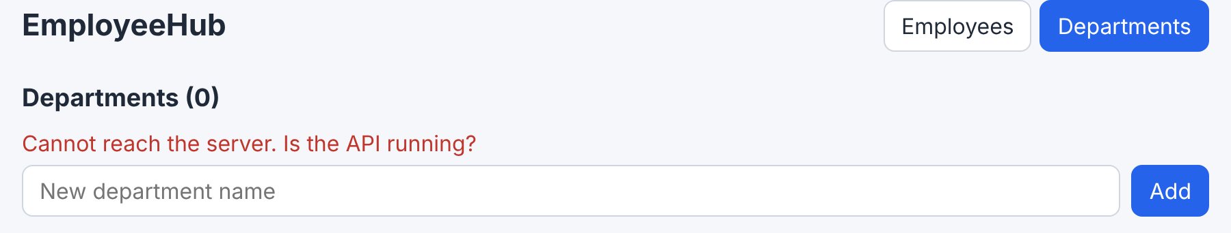
Screen · the server is stopped

Lab
- Show the number of employees next to each department name on the Departments page.
- Salary range filter: two number inputs sending ?minSalary=&maxSalary= (the server needs them too).
- Bonus: a /employees/:id page for one employee (useParams() + GET /api/employees/:id).
Solution 3 (bonus)
// App.jsx
<Route path="/employees/:id" element={<EmployeeDetailsPage />} />

// pages/EmployeeDetailsPage.jsx
import { useEffect, useState } from 'react';
import { Link, useParams } from 'react-router-dom';
import api from '../api';

export default function EmployeeDetailsPage() {
const { id } = useParams(); // the :id from the URL
const [employee, setEmployee] = useState(null);
useEffect(() => {
api.get(`/employees/${id}`).then((res) => setEmployee(res.data));
}, [id]);
if (!employee) return <p className="muted">Loading…</p>;
return (
<section>
<h2>{employee.name}</h2>
<p>{employee.jobTitle} · {employee.department?.name} · {employee.salary.toLocaleString()} EGP</p>
<Link to="/employees">Back</Link>
</section>
);
}

// EmployeeRow.jsx: the name becomes a link
<td><Link to={`/employees/${employee._id}`}>{employee.name}</Link></td>

If something stops
What you see | Why | Fix
Console: blocked by CORS policy | cors missing on the server, or after the routes | app.use(cors(...)) before the routes, restart
"Network Error" / "Cannot reach the server" | The server terminal is stopped | npm run dev inside server
A white page | A JavaScript error | F12 → Console: usually a wrong import or a lowercase component name
Changed .env and nothing changed | Vite reads .env at start | Stop and start npm run dev in client
<Link> may be used only in the context of a <Router> | BrowserRouter does not wrap App | main.jsx
does not provide an export named ... | import { X } for a default export, or the reverse | Default: import X from · named: import { X } from
Everything gets deleted when the page opens | onClick={onDelete(x)} | onClick={() => onDelete(x)}
Added, but the list did not change | push on the old array | [...list, item]
Requests repeat forever | Loading in the component body, or useEffect without [] | Load inside useEffect with its dependency array
The Department column is empty | The server does not populate the department | Session 2: .populate('department', 'name')
Warning: Each child in a list should have a unique "key" | map without key | key={item._id}
Each GET appears twice in the server terminal | StrictMode (development only) | Normal

Say to the trainees
Wrap-up: "Tomorrow, the last session: we put the whole project online with Atlas, Render and Vercel, and it gets a real link."

